Post Management:
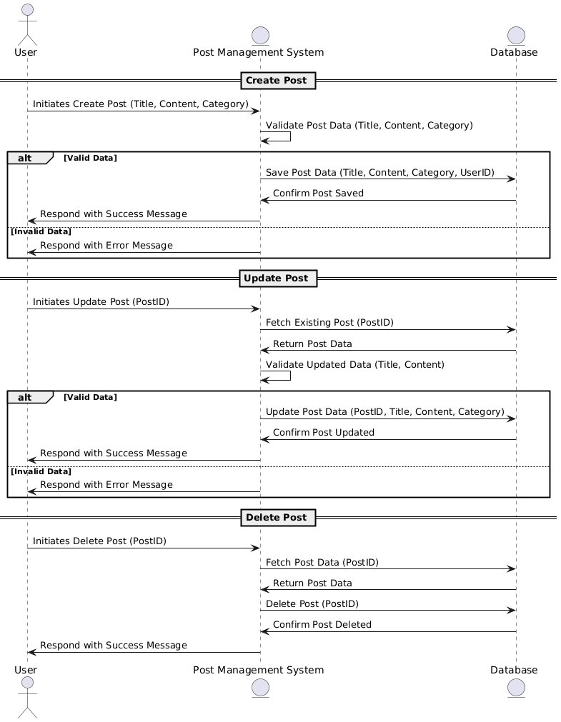
Database:
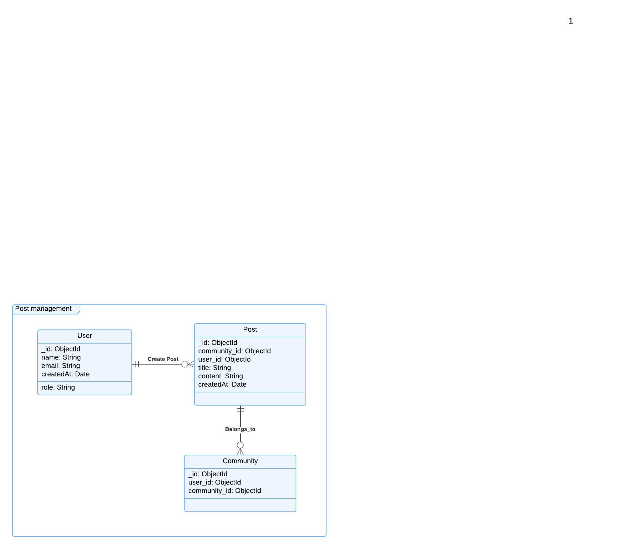
Functional Requirements (FRs)
Post Creation:
- FR1: Users must be able to create posts with a title, content, and timestamps (created_at, updated_at).
- FR2: Each post must be associated with a user (the creator of the post).
Post Editing:
- FR3: Users must be able to edit their own posts (title, content, tags, etc.).
- FR4: The system must log the history of changes made to a post, including who made the change and when.
Post Deletion:
- FR5: Users must be able to delete their posts.
- FR6: The system must confirm that a user wants to delete a post to prevent accidental deletions.
Commenting on Posts:
- FR7: Users should be able to comment on posts.
- FR8: Users should be able to edit and delete their comments.

Non-Functional Requirements (NFRs)
- NFR1: The system should be able to handle at least 5,000 posts and 100,000 comments concurrently with minimal latency.
- NFR2: Post creation, editing, and deletion should be processed within 2 seconds for a smooth user experience.
Usability:
- NFR3: The user interface for post creation, editing, and commenting should be user-friendly and intuitive.
- NFR4: The system should provide a preview feature before posting or editing content.
- NFR5: The system should be mobile-friendly to allow users to manage posts and comments on various devices.

Announcements Management:
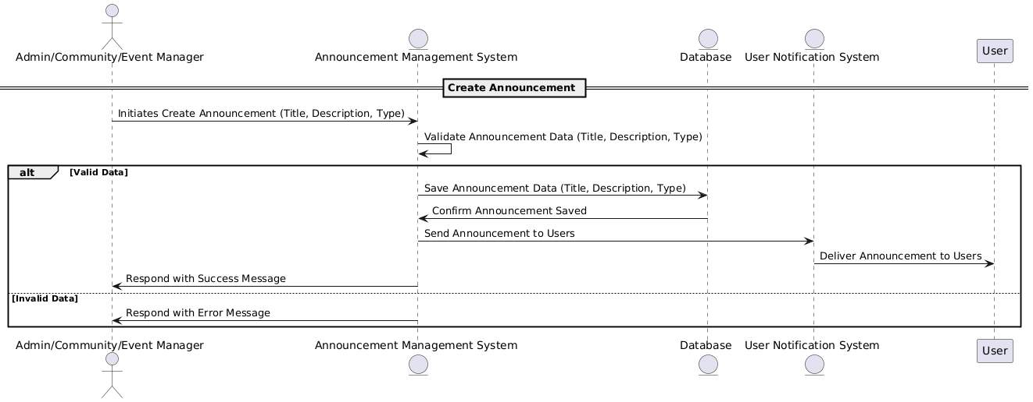

Database:
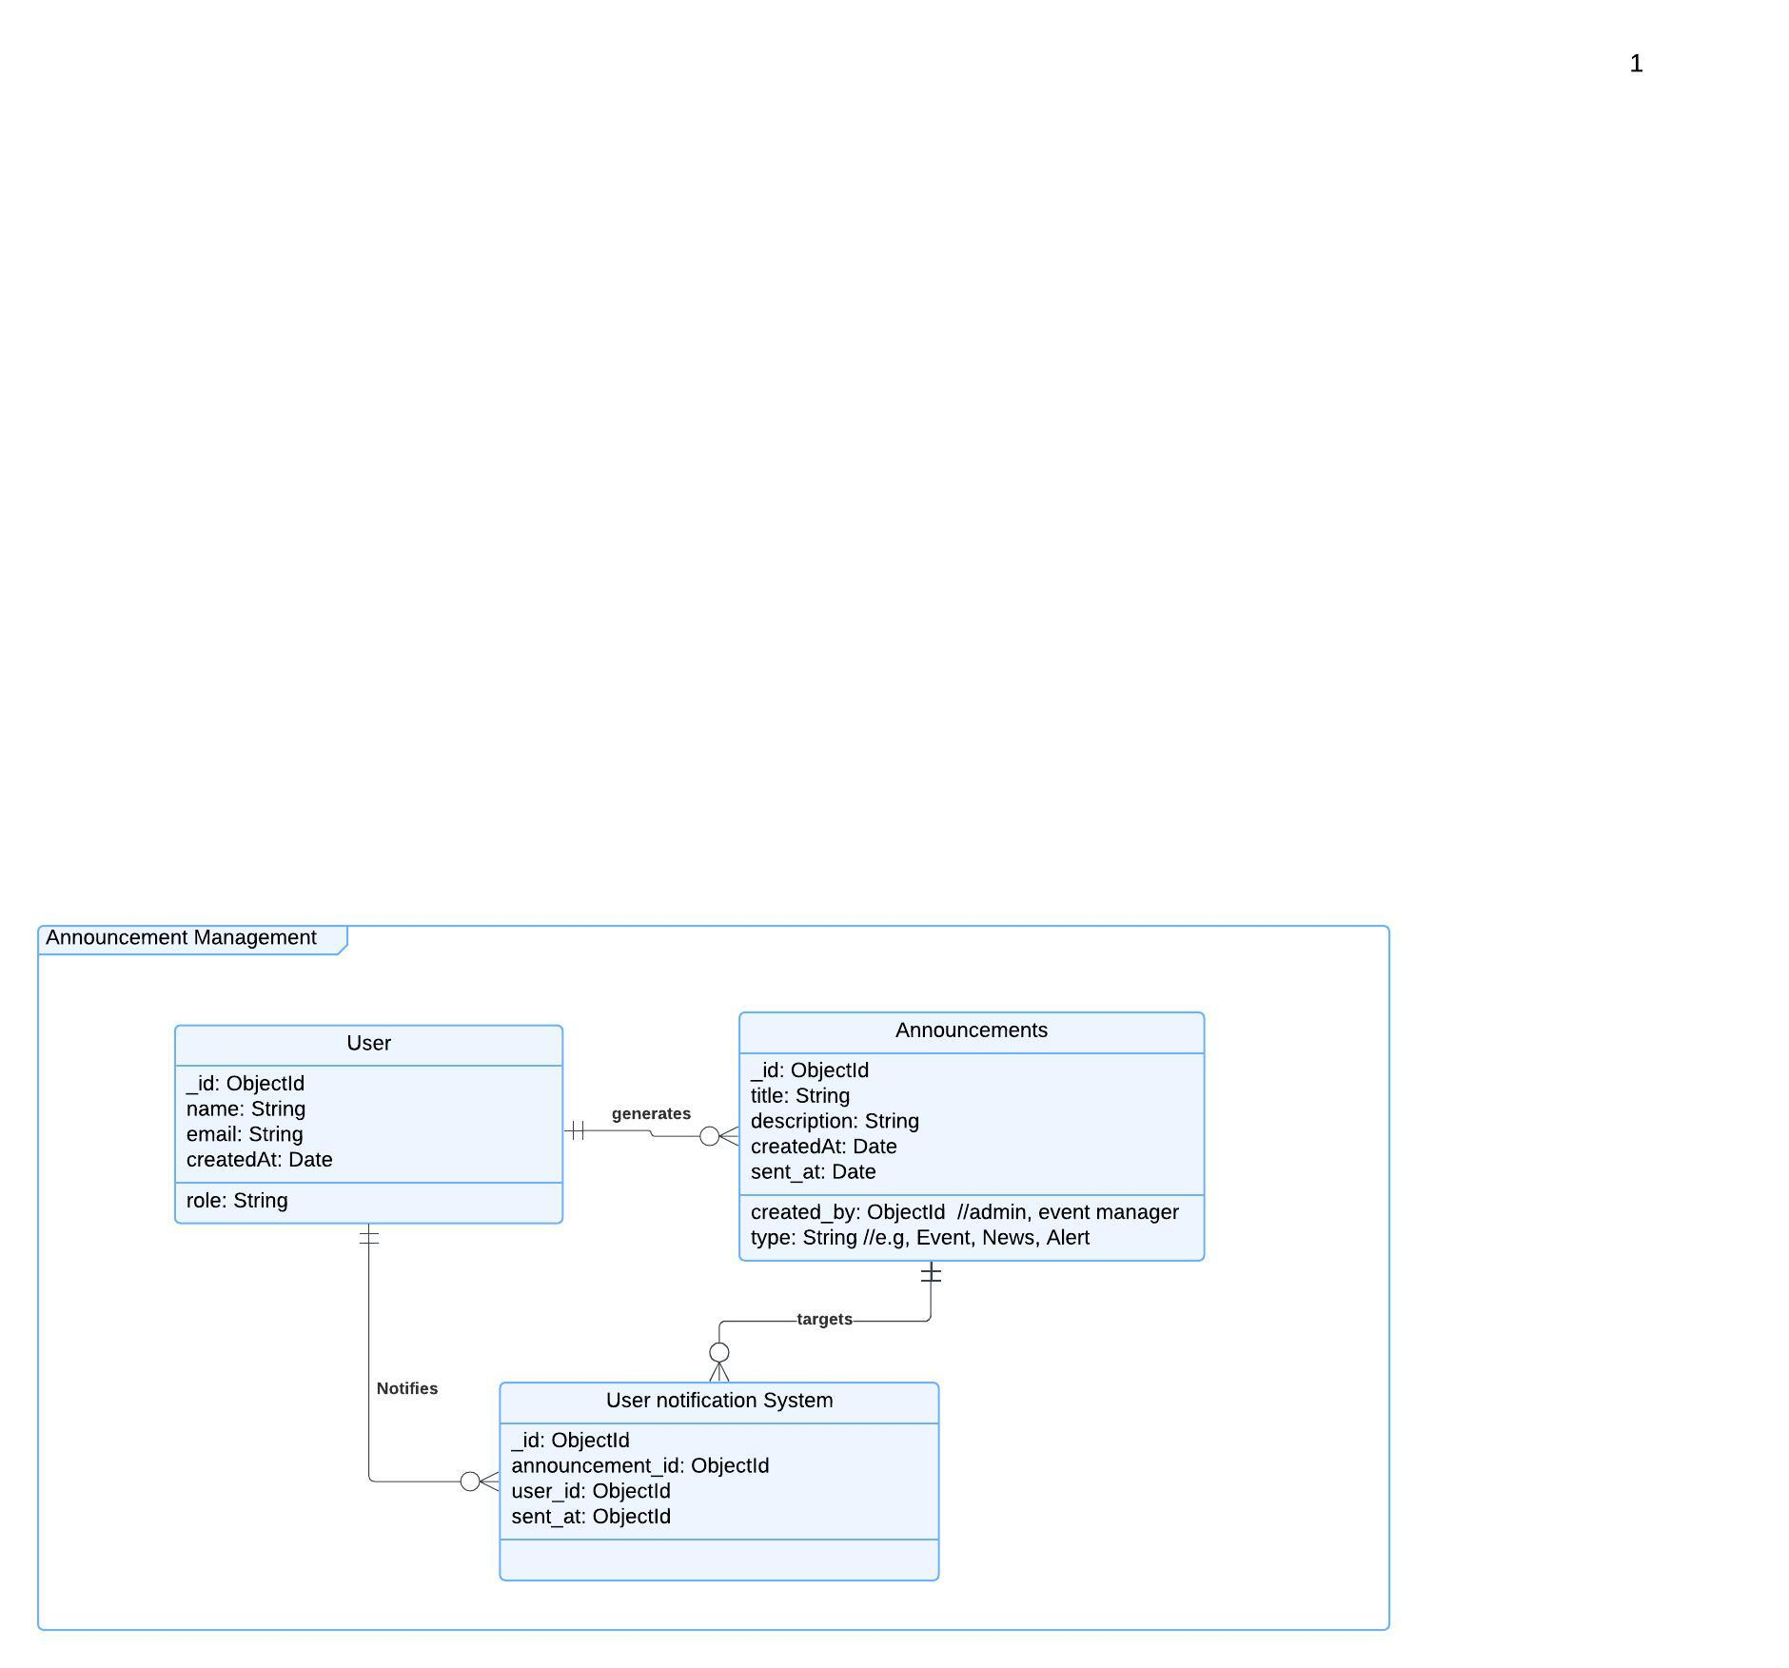
Functional Requirements (FRs)
User Management:
- FR1: The system must allow users to register with a unique username, email, and role (Admin, Manager, etc.).
- FR2: The system must store and manage user information, including a creation timestamp.
- FR3: Users must be able to log in using their username and email
Announcement Management:
- FR4: Admin users must be able to create, update, and delete announcements.
- FR5: An announcement must have a title, description, type, and timestamps (created_at and sent_at).
- FR6: The system must allow admin users to specify the type of announcement (e.g., Event, News, Alert).
User Notification System:
- FR7: The system must send notifications to users when an announcement is created.
- FR8: The system must track the timestamp when each notification is sent.
- FR9: Users must receive notifications for announcements that are relevant to them (determined by their role or preferences).
- FR10: The system must allow users to view a list of notifications they have received.
Non-Functional Requirements (NFRs)
Performance:
- NFR1: The system should be able to handle at least 1,000 concurrent users creating announcements and receiving notifications.
- NFR2: Notifications should be delivered within 5 seconds of announcement creation or update.
Security:
- NFR3: User data (e.g., username, email) must be encrypted and securely stored.
- NFR4: Users should have role-based access control (RBAC) to restrict access to announcements (e.g., only admin users can create/edit announcements).
- NFR5: Notifications must be delivered through secure channels (e.g., encrypted email or push notifications).

